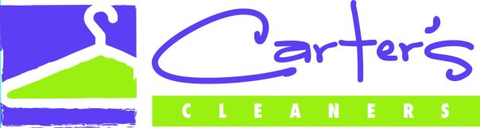

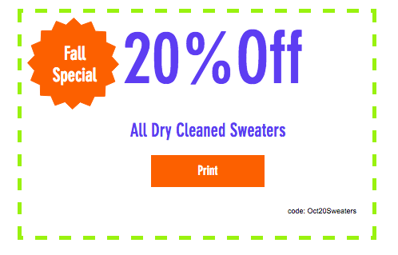

Locations:
Carter’s Dry Cleaners 414 Main St Everett, MA 02149
(617)-387-2483
Carter’s Dry Cleaners 132 Dodge St Beverly, MA 01915
(978)-922-3863
Carter’s Dry Cleaners 165 Pleasant St Marblehead MA, 01945
(781)-639-2131

